Whale Racing User Manual

1. INTRO
2. History
3. Development
4. How To Play
5. Starter’s Guide
6. Gameplay Controls
7. Singleplayer and Multiplayer
8. Splitscreen
9. Racetrack Obstacles
10. Checkpoints
11. Powerups
12. Roadblocks
13. Maps
14. Aduloo
15. Shipyard
16. Minefield

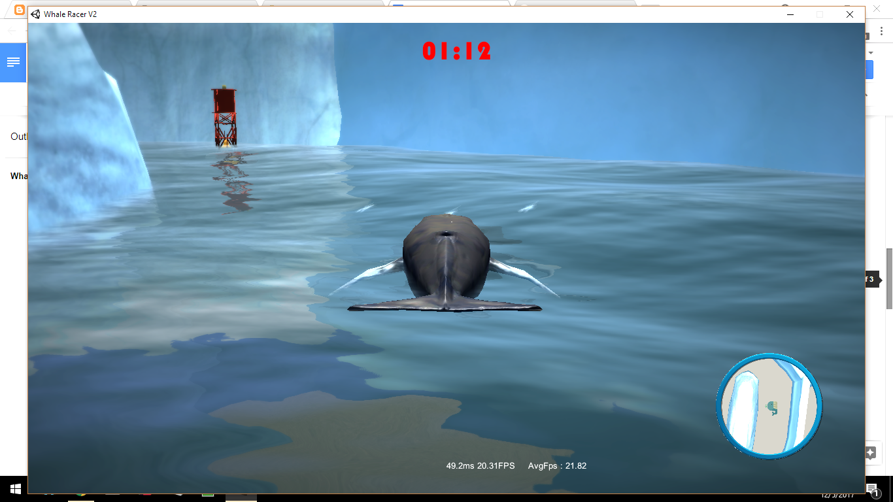

# INTRO

## History

To us, the days of whale racing is but yesteryear in antiquity. For millennia, whales have been racing up and down coasts, within the arctic circle, along the crests of the Antarctica and beyond. The races continue to this day, but have almost ceased due to the major impact of whaling long ago. The wondrous rush of waves that crosses the fins of a whale in the midst of water crash, tumble, and splash echoes into dystopia. From shore to shore, one whale will be victorious.

## Development

In the year, 2013, the idea of a game to honor whales was formed. Initially, the game was nothing but scraps to be fed to wolves, but over time became a corporeal overture to whale racing. Over the years, 2014, 2015, 2016, the game slowed to limp in development until in 2017 it saw a final chance to find its own realization.

In the beginning of 2017, Austin Irvine, the creator of the game, began by developing platitudes of art assets inspired from years of thought. The development of the game pushed forward until a barrier was hit. The game wouldn’t be able to succeed without a team of developers. He knew it as did people around him.

Towards the end of 2017, a team of developers along with Austin, picked the game up from the pile of melted cartridges and laid the foundation for a new era of whale racing. Development has spanned for about a month now. The features in the game range from singleplayer, ai whales, multiplayer matches, all the way to advanced sea diving. There is much to expand on the game.

Roam the waves!

# How To Play

## Starter’s Guide

When you reach the main menu, there are a couple things you can do to increase your experience.

* Controls - this will remind you of what keys control your whale
* Options
  + Adjust Audio For Music, Game, and Environmental Sounds

Once you have read and changed everything you want in the control and option menus, you can click play to run the game. In the play menu, you have several other options.

1. Select A Map
2. Select Number of Laps

After you have selected the map and number of laps, continue to the next menu. The next menu will allow you to select whether you want to play singleplayer, splitscreen, or multiplayer LAN. From there, the game has some major differences.

Single Player - You will start playing the game.

Splitscreen - You and a friend will start playing the game.

Multiplayer - You will be taken to an online lobby. There you can host or join a game. Click “start” when ready to play the game and it will load soon after.

* Host - Host a game and wait for a friend to join on a LAN connection.
* Client - Input an IP Address to join.

## Gameplay Controls

The control scheme for the game is similar to most FPS controlled games. The layout for singleplayer and LAN multiplayer is below.



### Singleplayer and Multiplayer

|  |
| --- |
| * **W -** Forward Movement * **S -** Backward Movement * **A -** Rotate Left * **D -** Rotate Right * **Q -** Quick Turn Left * **E -** Quick Turn Right * **Left Shift**  - Sprint * **Left Alt**  - Blowhole * **Left CTRL** - Submerge Underwater * **Spacebar**  - Jump or Move to Surface |

### Splitscreen

|  |  |
| --- | --- |
| **Player 1**   * **W -** Forward Movement * **S -** Backward Movement * **A -** Rotate Left * **D -** Rotate Right * **Q -** Quick Turn Left * **E -** Quick Turn Right * **Left Shift**  - Sprint * **Left Alt**  - Blowhole * **Left CTRL** - Submerge Underwater * **Spacebar**  - Jump or Move to Surface | **Player 2**   * **Up Arrow Key -** Forward Movement * **Down Arrow Key -** Backward Movement * **Left Arrow Key -** Rotate Left * **Right Arrow Key -** Rotate Right * **Colon Key -** Quick Turn Left * **Quote key -** Quick Turn Right * **Forward Slash** - Sprint * **Right Alt**  - Blowhole * **Right CTRL** - Submerge Underwater * **Right Shift** - Jump or Move to Surface |

By default, player 1 will be on the top screen. Playe 2 will be placed on the bottom screen.

# Racetrack Obstacles

## Checkpoints

**Buoys** resembles points in the map where you should head next and offer as markers confirming you are moving along the correct path.

## Powerups

**Krill** are edible powerups that can be used to temporarily get speed boosts while racing in the ocean.

## Roadblocks

**Boxes** are roadblocks that’ll push you back when you hit them. You want to avoid these to stay at the front of the race.

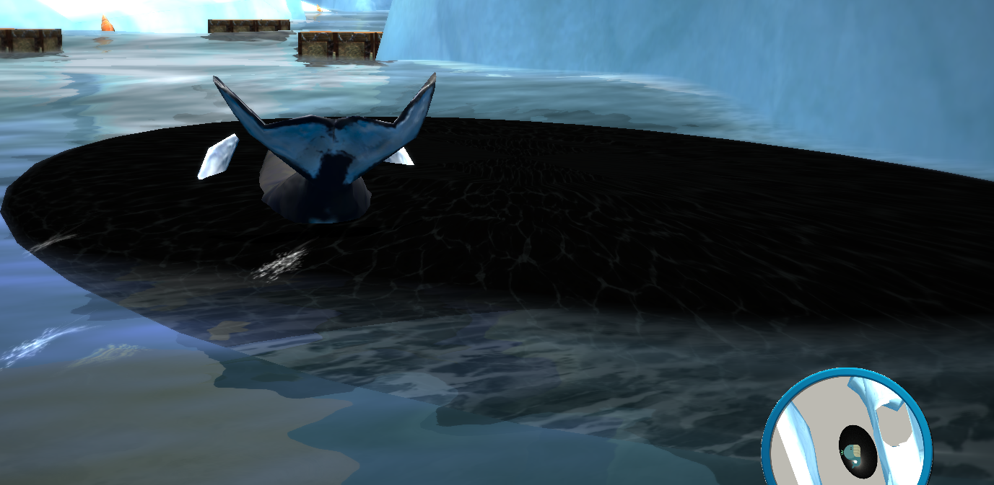

**Oil slicks** are dangerous to interact with as they slow down your whale and greatly reduce your chances at getting first place in the race.

# Maps

All the maps are located in the arctic.

## Aduloo

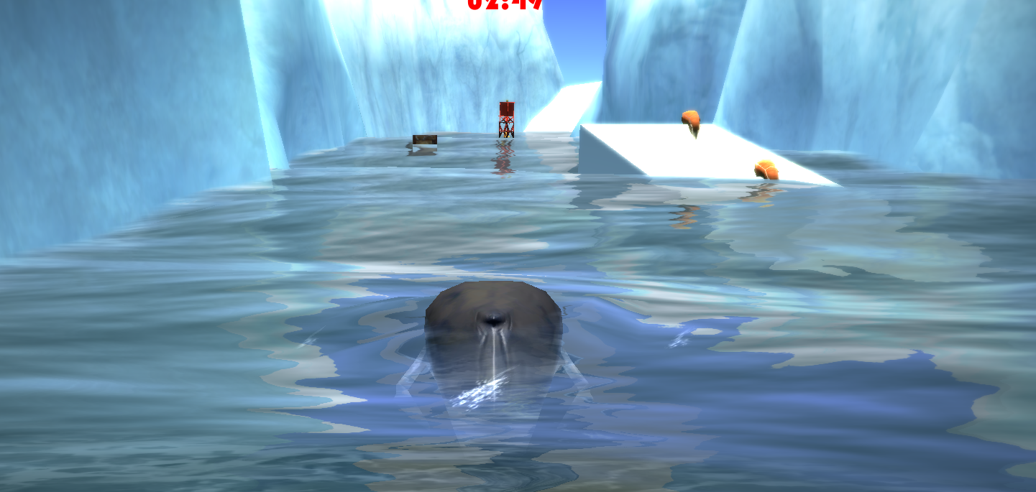

## Shipyard

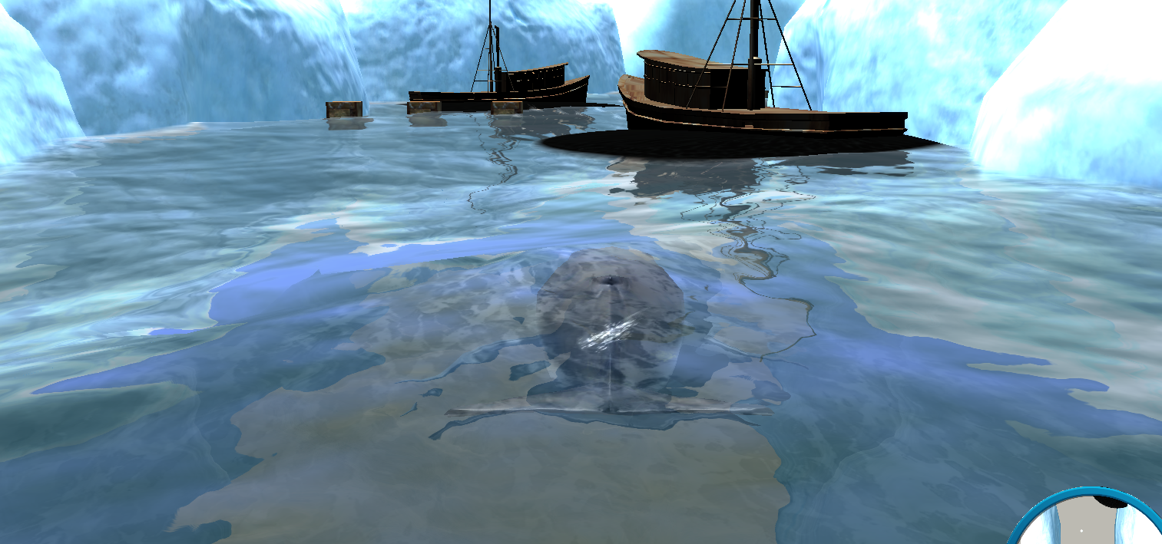

## Minefield

